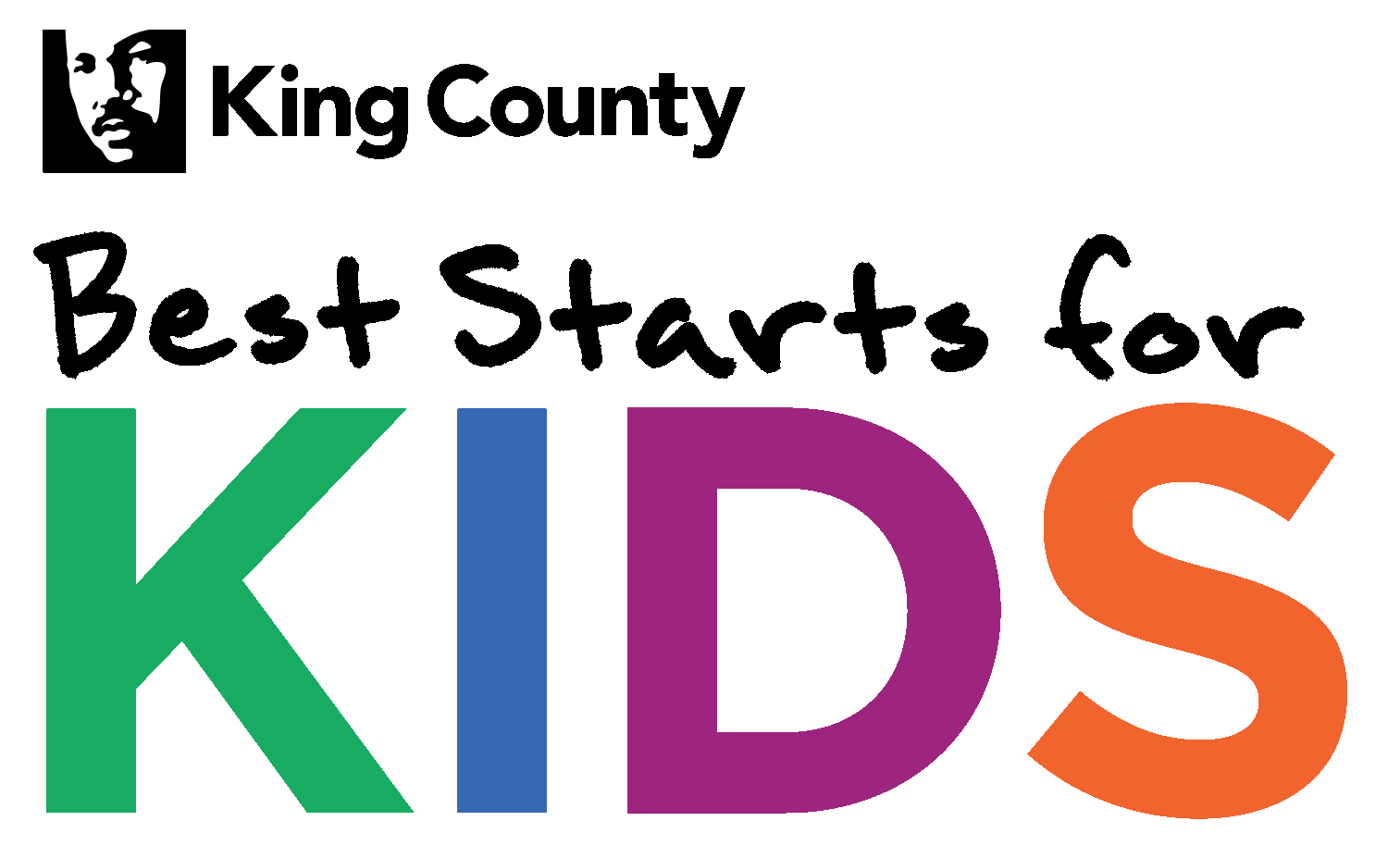
BSK School based SBIRT District Partner Questionnaire
Please briefly answer the following questions and email this form to Margaret Soukup at margaret.soukup@kingcounty.gov by June 14th, 2017.
Limit responses to no more than 3 pages.

 | Question | District Partner Answer
 | Will you commit to creating a plan for implementing SBIRT model in middle schools in y? | ☐Yes, commit to implementing SBIRT model in middle schools
 | Identify proposed middle schools who will participate in the planning.
 | Provide one paragraph on current behavioral health prevention/promotion activities (in each school identified above). | In the format of MTSS: Tier 1, Tier 2 and Tier 3.  http://k12.wa.us/MTSS/default.aspx
 | Provide a paragraph on behavioral health prevention/promotion resource gaps/needs (in each school identified above). | In the format of MTSS: Tier 1, Tier 2 and Tier 3.
 | Identify any community-based organizations that school district/middle schools are currently working with on behavioral health services.
 | Do you commit to assigning staff/point person (at district and school levels) or do have someone already identified, for the planning process within 90 days of receipt of planning award? | ☐Yes, commit to hiring or assigning staff
 | What would you like your district to gain from participation in the planning project? | ☐ Substance abuse prevention  ☐ Mental health promotion  ☐ Truancy intervention or prevention  ☐ Trauma informed services  ☐ Restorative principles  ☐ Suicide prevention  ☐ Social Emotional Learning  ☐ Early Intervention  ☐ Community linkages and referral & anything else:

